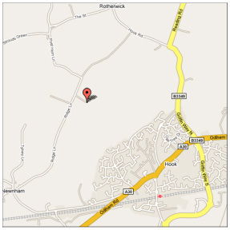 | Easter Camp and Folkmoot 2009  Friday 10 – Monday 13th April  At The Gordon Brown Outdoor Education Centre, Rotherwick, Hook, Nr Basingstoke, Hants RG27 9AT
This is a beautiful site that we’ve used many times with plenty of room for indoor and outdoor activities and opportunities for lovely walks. Bunks are available at a slightly higher cost if you don’t fancy camping. There will be group catering throughout the weekend – please let us know in advance if you have any special dietary requirements for food, vegetarian/vegan options will be available – again please let us know if this applies to you.  Costs; £5 per adult per day for food (approx)  £7 per adult per night for indoor sleeping  £4 per child per night  £4 per adult per night camping  There will be the usual cap available for kindreds, and reduced costs for unwaged adults. If you are concerned about costs, please contact Merlin (Keeper of the Purse) as we never want this to stop people attending.  Please let us know asap how many of you will be joining us for the weekend – we look forward to seeing you there!  Sheena Mapson (Camp Convenor)  sheenatutt@hotmail.com  94 Colston Rd, Easton, Bristol BS5 6AD  0117 9393877 / 07854326729  Charlotte Jones (Keeper of the Fire, Camp Caterer)  charlotte@mor-cott.co.uk  Morland Cottage, Peak Lane, Compton Dundon, Somerton, Somerset TA11 6PE  01458 272531  Please be aware that changes in the programme are subject to the weather! | - Good Friday – Opening Ceremony @ 4pm followed by dancing and ceremonial cake  Dinner for all  - Saturday morning – Hovercraft building and racing – please bring sports caps from water bottles, essential component  Saturday afternoon – outdoor activities (weather permitting), indoor if not  Saturday evening – Campfire, Fish and chip supper for all willing, Folkmoot business session after dinner  - Sunday morning – a visit from our friend the Easter Bunny, with hunt the Easter egg tree and guess-how-old the oldies are!  Circus skills workshop, outside weather permitting  Sunday afternoon - Massage/reiki workshop  Sunday evening – Campfire, Folkmoot business session after dinner, followed by Sing the Sig  - Monday morning – Closing ceremony  Clearing the site – we ask that everyone be available to clear the site of all rubbish etc before leaving  There will be archive material such as photo albums of previous camps available for everyone to look through throughout the weekend – please bring along anything you have that may be of interest  Please bring any indoor craft/games activities you have in case of un-sunny weather!  If you can bring a cake/pudding to contribute to the ceremonial tea, please do

